**EXPERIMENT # 9**

**Aim: Study and Perform the Thevenin’s Theorem**

**Apparatus:**

1. Resistors (fixed and variable)
2. Multi-meter
3. Jumper Wires
4. Breadboard
5. DC Supply

**Objectives:**

1. Strengthening of concepts of Thevenin theorem **Pre-Lab:**

1. According to Thevenin theorem, any circuit while viewed from a specific pair of points can be reduced to a simple series circuit with a voltage source VTh and a series resistance RTh connected across that specific pair of points.
2. Both the original circuit and Thevenin's Equivalent Circuit are equivalent in terms of voltage and current at the specific pair of points.
3. The voltage source value is the open circuit voltage across the pair of points and the series resistance value is the resistance seen looking from the open circuited set of points and all voltage and current sources in the original circuit replaced with their internal resistances.
4. The internal resistance of a voltage source is connected in series with it and that of a current source is connected in parallel with it. This scheme is adopted to indicate the loss of voltage and current with change in loading.
5. Ideally, the internal resistance of a voltage source is 0, i.e. it can maintain the same voltage across its terminals regardless of the load being fed by it and that of a current source is , i.e. it can maintain a constant current through its terminals regardless of the load being fed by it.
6. Lab equipments have these source values approaching ideal, therefore, we shall be using the ideal approach while replacing sources with their internal impedances. **Procedure:**

1. Measure four resistors and construct a series circuit as shown below. A precaution for minimizing the source resistance effect is to use a high value resistor that is connected to positive battery terminal.

1

2

R

L

1. The specific set of points is 1 & 2, with respect to which, the circuit has to be Thevenized.
2. Measure and note V12 and I12 for different values of source voltage.
3. Remove resistance RL from the circuit and measure V12 for different values of source voltage (used in point 3 above) as shown below. This voltage is the Thevenin voltage VTh.

1

2

+

V

12

-

1. Turn of source supply and place a short circuit across voltage source as shown below. Measure resistance R12 which is the Thevenin resistance RTh.

1

2

R

12

1. Construct the Thevenin equivalent circuit and connect RL between points 1 & 2 as shown below with source voltage adjusted to values of VTh (obtained in point 4 above). RTh value will be obtained using a variable resistance.

R

Th

R

L

1

2

V

Th

1. Measure V12 and I12 and compare with the results obtained in 3 above.

**Verification:**

|  |  |  |  |  |  |  |  |
| --- | --- | --- | --- | --- | --- | --- | --- |
| **S.**  **No.** | **Source voltage**  **(Volt)** | **Measurements in Original Circuit** | | **Thevenin Voltage VTh**  **(Volt)** | **Thevenin**  **Resistance**  **RTh**  **(Ω)** | **Measurements in**  **Thevenin**  **Equivalent Circuit** | |
| **V12 (Volt)** | **I12**  **(Amp.)** | **V12 (Volt)** | **I12**  **(Amp.)** |
|  |  |  |  |  |  |  |  |
| **1.** | **12** | **2.4** | **4.004m** | **6** | **500** | **2.4** | **4m** |
| **2.** | **5** | **1** | **1.67m** | **2.5** | **500** | **1** | **1.67m** |
| **3.** | **9** | **1.8** | **3m** | **4.5** | **500** | **1.8** | **3m** |

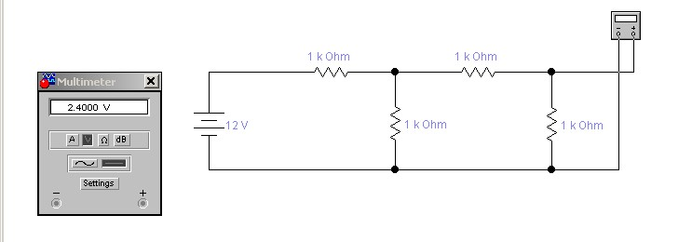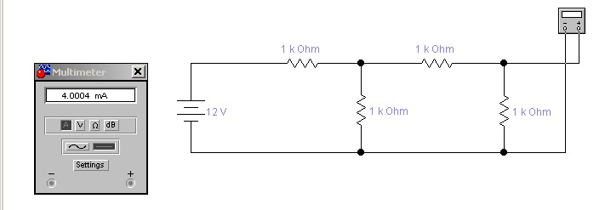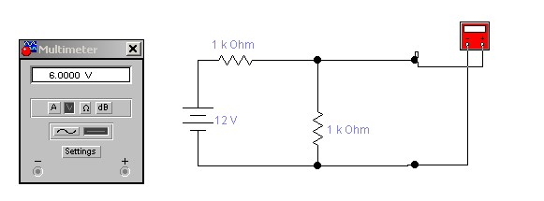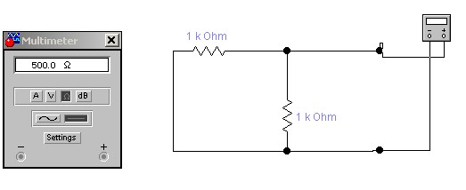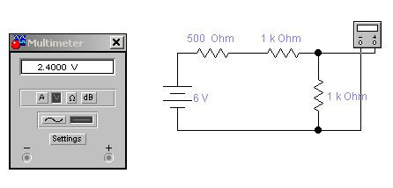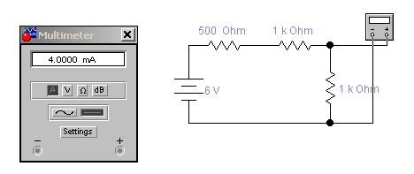

INSTRUCTOR VERIFICATION SHEET

For each verification, be prepared to explain your answer and respond to other related questions that the lab TA’s or Instructors might ask.

Name: Date of Lab:

Q. No. 01

Q. No. 02

## Q. No. 03

Verified: Date/Time: